**Give Feedback**

1) As you search through the source code note any bugs you find. How do you think

you could fix them?

- Added PrintFood() method after every turn so the user can see remaining food units along with water

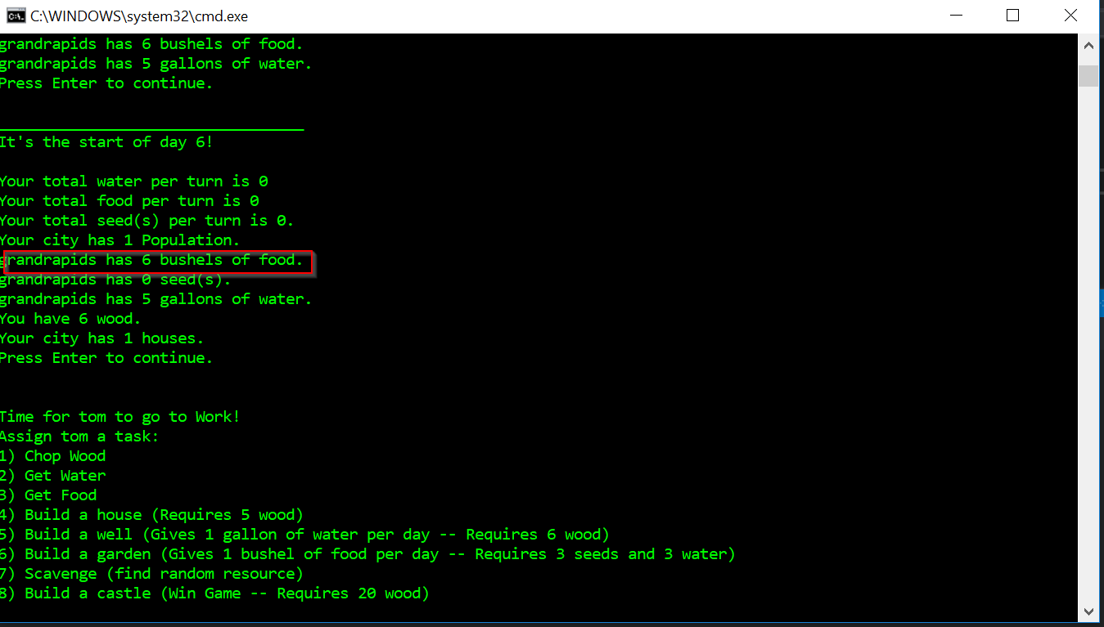

-The naming convention was according to Java Best Practices not C# best practices.

2) Refactor: is there a class/method that could be cleaner? How would you suggest

cleaning it up?

Code Review and Refactoring:

Replace GetPop() with property Pop

1. public int Pop
2. {
3. get
4. {
5. return villagers.Count;
6. }
7. }

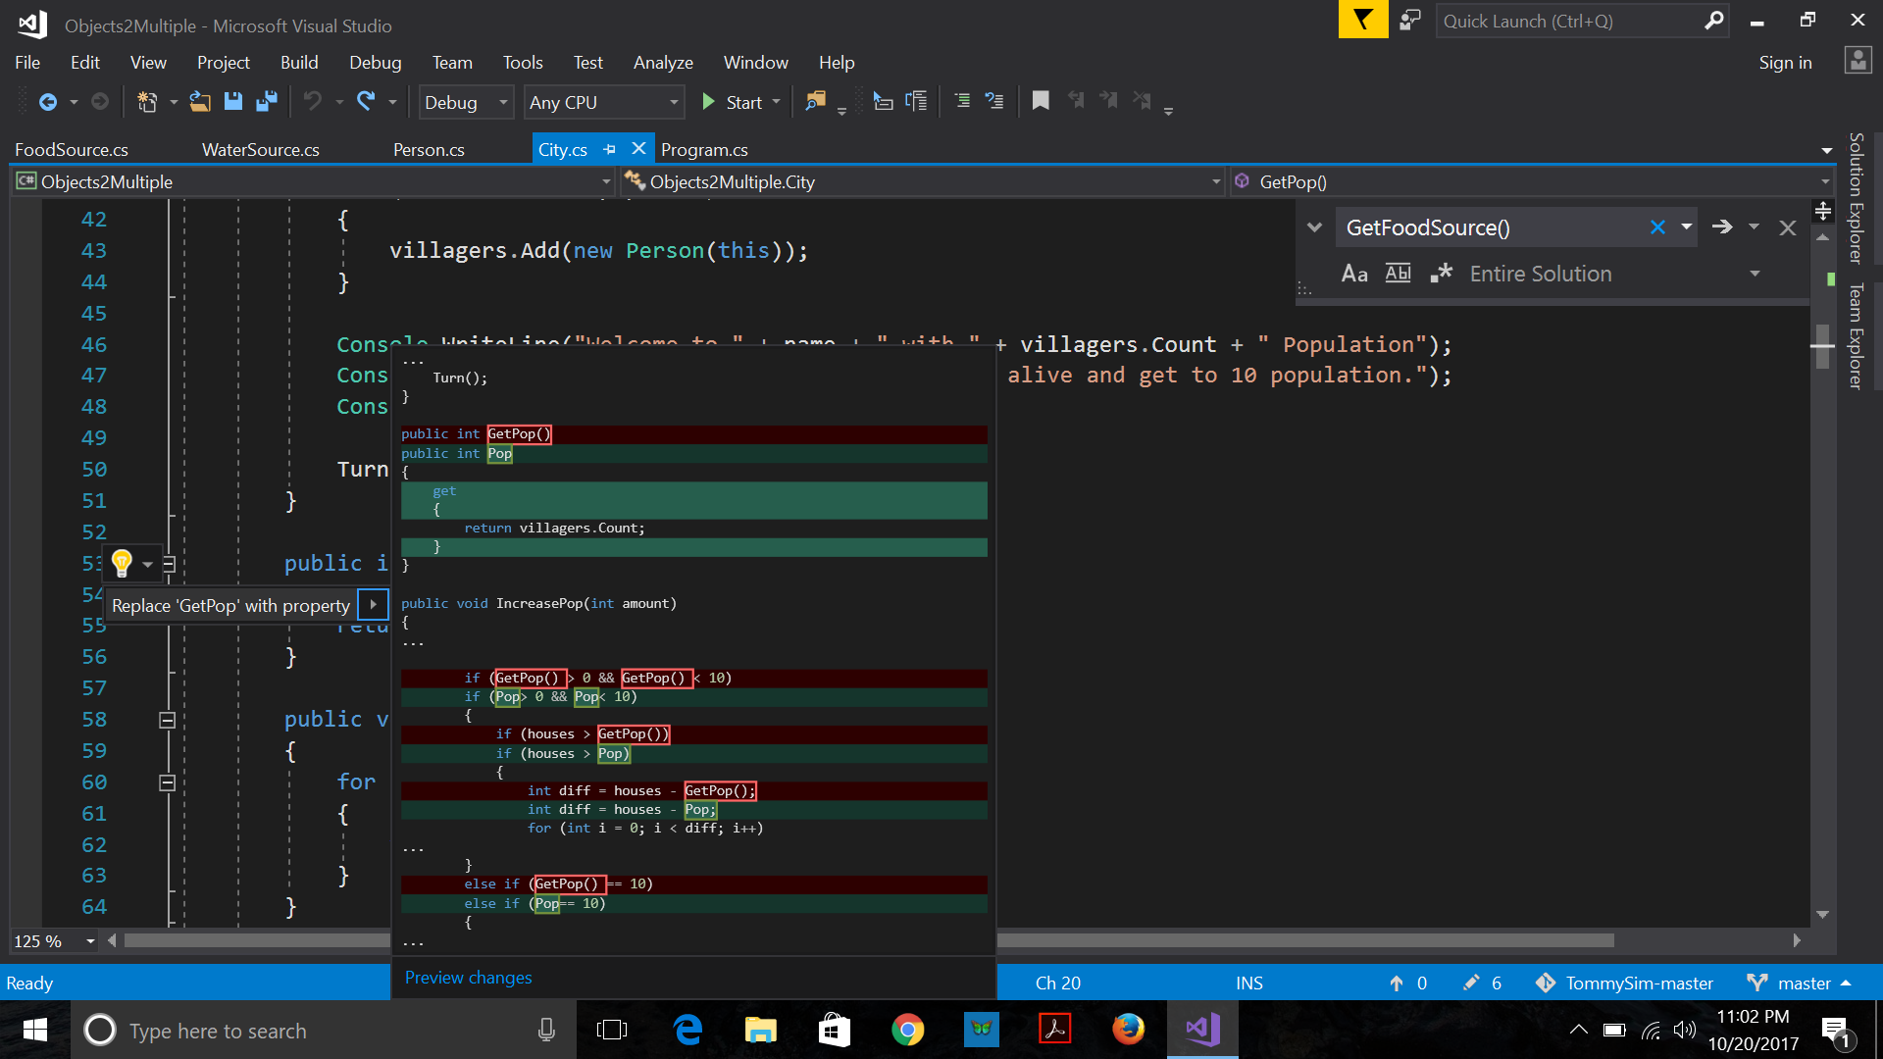

2. Clean up the string[] resource to mention only the resources we are using

string[] resources = { "wood", "water", "food", "nothing", "death", "seed", "disease","barbarians" };